LASSN

English at Home

Resource pack

Health 1:

Parts of the body



Many students want to manage medical appointments without interpreters. The topic of ‘health’ could easily take 6 months. These sub-topics might not be taught in this order, and may not all be needed.

1. **Parts of the body**
   * body and head/face - singular and plural
2. **Symptoms and illnesses**
   * symptoms – I feel/I’ve got/My _____ hurts
   * adult illnesses – mental and physical
   * common childhood illnesses
3. **The NHS**
   * What it is
   * Components eg GP, Walk-in Centre, A&E
   * Staff eg GP, practice nurse, counsellor
4. **Making and changing a GP appointment**
   * Vocabulary eg Receptionist, waiting room, desk
   * Day, date, time, DOB, address
   * Prepositions (on Monday, at 9am)
   * For yourself, for someone else
   * Polite requests and checking back
5. **Talking to the GP**
   * Putting language learned above into sentences
   * Greetings/goodbyes/conversation structure
   * Language for instructions and procedures eg lie down, test
   * Past/present/future tenses
6. **Prescriptions**
   * Understanding the document and what to do with it
   * Who gets free prescriptions?
7. **Medicines etc.**
   * Medicines and non-medicines eg plasters, bandage, anti-bac.
8. **Home and ’alternative’ remedies**
9. **Buying something at the chemists**
   * Putting language learned into sentences and a new context
   * Simple questions/requests
10. **Understanding hospital appointment letters**
    * Format of a formal letter. Day, date, time again
11. **Changing an appointment or booking an interpreter**
    * Polite requests and checking back
12. **More complex language for symptoms, illnesses and treatments** associated with hospital appointments
13. **Having a baby**
    * Roles of different health professionals eg health visitor
    * Entitlement to benefits, specialist services, post-natal services etc.
14. **Healthy eating**
15. **Giving advice**
    * Where to go for which problem eg not to A&E for a headache
    * Advising a friend – you should/shouldn’t

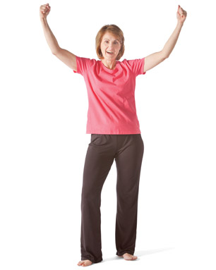

head fingers thumb wrist

arm elbow shoulder neck

chest tummy hip leg

knee ankle foot toes

**___________________________________________**

h_ _ _ f_ _ _ _ _ s th_ _ _ w_ _ _ _

a_ _ e_ _ _ _ sh_ _ _ _ _ _ n_ _ _

ch_ _ _ t_ _ _ y h_ _ l_ _

k_ _ _ a_ _ _ _ f_ _ _ t_ _ s

**_________________________________________________**

This is my ___________________ .

I have ________ ____________s.

My ____________ hurts.

|  |  |  |  |
| --- | --- | --- | --- |
| head | fingers | thumb | wrist |
| arm | elbow | shoulder | neck |
| chest | tummy | hip | leg |
| knee | ankle | foot | toes |

cut out and place on the picture

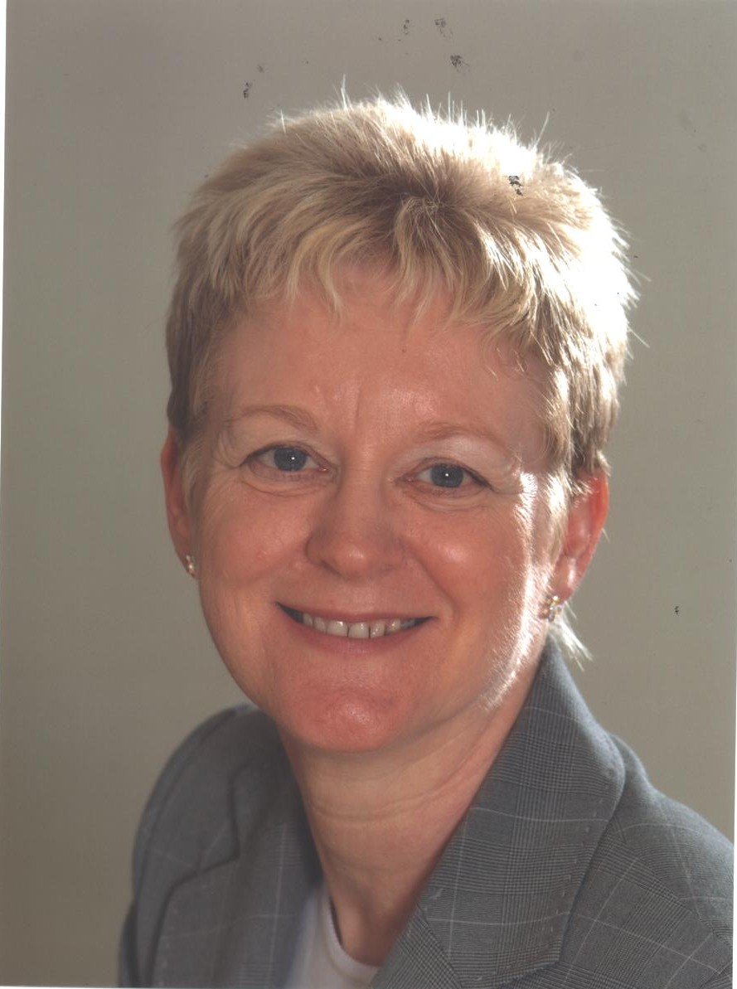

**head forehead eye nose**

**cheek mouth chin neck tooth/teeth**

**lip ear eyelash eyebrow**

**h_ _ _ f_ _ _h_ _ _ e_ _ n_ _ _**

**c_ _ _ k m_ _ _ _ c_ _ _ n_ _ _**

**t_ _th/t_ _ _ _ l_ _ e_ _ e_ _l_ _ _**

|  |  |  |
| --- | --- | --- |
| head | forehead | eye |
| nose | cheek | mouth |
| chin | neck | lip |
| ear | eyelash | eyebrow |
| tooth/teeth |  |  |

cut out and place on the picture

|  |  |
| --- | --- |
| [http://www.clker.com/cliparts/d/f/a/a/11954446181571546372ryanlerch_boyface3_outline.svg.med.png](http://www.google.co.uk/url?sa=i&rct=j&q=&esrc=s&source=images&cd=&cad=rja&uact=8&docid=ZNaKcmD1TrDB4M&tbnid=hkjJ2NgkwAZWsM:&ved=0CAUQjRw&url=http%3A%2F%2Fwww.clker.com%2Fclipart-12166.html&ei=mYjfU4W-Iu6X0QXnloGYBg&bvm=bv.72197243,d.d2k&psig=AFQjCNFxzrM2SvEySY01o9UIWndJNSZ0bg&ust=1407244798460573) | **head** |
| [http://www.almuderis.com.au/media/k2/galleries/189/002_elbow_intercondylar_fracture.jpg](http://www.google.co.uk/url?sa=i&rct=j&q=&esrc=s&source=images&cd=&cad=rja&uact=8&docid=fRSaw4lpEUN-_M&tbnid=O9-y5sD6APpIOM:&ved=0CAUQjRw&url=http%3A%2F%2Fwww.almuderis.com.au%2Fcomponent%2Fk2%2Fitem%2F189-elbow-intercondylar-fracture&ei=7YjfU-S3FoWe0QWGmICQCA&bvm=bv.72197243,d.d2k&psig=AFQjCNFooUdAL7x1NM2s5M3Ca95s62-Zaw&ust=1407244885933130) | **elbow** |
| [http://www.newscientist.com/blog/lastword/uploaded_images/071024_finger_roll-798191.jpg](http://www.google.co.uk/url?sa=i&rct=j&q=&esrc=s&source=images&cd=&cad=rja&uact=8&docid=sM_GOJgOYF6PpM&tbnid=EBJfDeK1peMJSM:&ved=0CAUQjRw&url=http%3A%2F%2Fwww.newscientist.com%2Fblog%2Flastword%2F2007%2F05%2Ffinger-roll.html&ei=HIrfU9K_IKi40QXH34DgCA&bvm=bv.72197243,d.d2k&psig=AFQjCNE1DKkoPXxAlGZcH0xhABEfALiD0w&ust=1407245206484399) | **fingers** |
| [http://images.clipartpanda.com/shoulder-clipart-dc6enK4qi.gif](http://www.google.co.uk/url?sa=i&rct=j&q=&esrc=s&source=images&cd=&cad=rja&uact=8&docid=BvmrrxOKNhuJxM&tbnid=X573lcw1psnD9M:&ved=0CAUQjRw&url=http%3A%2F%2Fwww.clipartpanda.com%2Fcategories%2Fshoulder-20clipart&ei=b4rfU4arJ-Sk0QXiyoCQCw&bvm=bv.72197243,d.d2k&psig=AFQjCNEI2onh0uC7krV5pDx0p8bTsW1ByA&ust=1407245280128008) | **shoulder** |
| [http://photos2.demandstudios.com/dm-resize/photos.demandstudios.com%2Fgetty%2Farticle%2F74%2F161%2F78400262_XS.jpg?w=202&h=10000&keep_ratio=1](http://www.google.co.uk/url?sa=i&rct=j&q=&esrc=s&source=images&cd=&cad=rja&uact=8&docid=-WrNWrCN--R-WM&tbnid=qLr0xVyi07PSbM:&ved=0CAUQjRw&url=http%3A%2F%2Fwww.livestrong.com%2Farticle%2F516880-at-home-leg-exercises-for-women-with-blood-clots-in-the-legs%2F&ei=6YrfU6rePKiR0QXtooCYDA&bvm=bv.72197243,d.d2k&psig=AFQjCNFbl4gMbb-i-av1TF8hYuQ8b_voXw&ust=1407245399916670) | **leg** |
| [http://hackingintolife.files.wordpress.com/2011/08/thumb-up.gif](http://www.google.co.uk/url?sa=i&rct=j&q=&esrc=s&source=images&cd=&cad=rja&uact=8&docid=5vMr7FAE02lPcM&tbnid=gv4naSB403RXmM:&ved=0CAUQjRw&url=http%3A%2F%2Fhackingintolife.wordpress.com%2F2011%2F08%2F16%2Fnervous-heart-racing-blow-on-your-thumb%2F&ei=FIvfU-rPGqjL0QWsxYHQDQ&bvm=bv.72197243,d.d2k&psig=AFQjCNHt61f0kBnfHBvXAlvrhrr9g9ARvw&ust=1407245452371645) | **thumb** |
| [http://3.bp.blogspot.com/-DDVbBb2EsjM/TshUbVIJf_I/AAAAAAAACdM/NQP1VIV6Bf4/s1600/la-phys.nice-neck-250.jpg](http://www.google.co.uk/url?sa=i&rct=j&q=&esrc=s&source=images&cd=&cad=rja&uact=8&docid=BrcOeDRAk5-uEM&tbnid=YQ2H9oBvc1MUxM:&ved=0CAUQjRw&url=http%3A%2F%2Fdietideassite.blogspot.com%2F2011%2F11%2Fhow-to-lose-neck-fat.html&ei=S4vfU5uiHumo0QXLroH4CQ&bvm=bv.72197243,d.d2k&psig=AFQjCNF6oPFWITAyDXAef3swh-41v3Q4hQ&ust=1407245507253231) | **neck** |
| [http://www.clker.com/cliparts/6/R/C/e/q/y/knee-md.png](http://www.google.co.uk/url?sa=i&rct=j&q=&esrc=s&source=images&cd=&cad=rja&uact=8&docid=fC6xUMd-3EnXSM&tbnid=1_xEJHY7Cq3uTM:&ved=0CAUQjRw&url=http%3A%2F%2Fwww.clker.com%2Fclipart-knee.html&ei=dovfU965MIKe0QX6xICIBQ&bvm=bv.72197243,d.d2k&psig=AFQjCNEDTb0fymRvGU1ViUGWwmrtBSH6rQ&ust=1407245551305060) | **knee** |
| [http://www.sportsmd.com/portals/0/altman2/ganglion_cyst.jpg](http://www.google.co.uk/url?sa=i&rct=j&q=&esrc=s&source=images&cd=&cad=rja&uact=8&docid=N7n33To9w5s4wM&tbnid=-IIOhUHFXlDokM:&ved=0CAUQjRw&url=http%3A%2F%2Fwww.sportsmd.com%2FInjuries_List%2Fid%2F4%2Fn%2Fwrist_injuries.aspx&ei=iY7fU7XWDIWn0AXekIDADw&bvm=bv.72197243,d.d2k&psig=AFQjCNFvV4L8wdJTID0ZG26v6M6Mjp4I7A&ust=1407246334664980) | **wrist** |
| [http://ak4.picdn.net/shutterstock/videos/2103899/preview/stock-footage-african-american-man-standing-looking-at-camera.jpg](http://www.google.co.uk/url?sa=i&rct=j&q=&esrc=s&source=images&cd=&cad=rja&uact=8&docid=oOX2WGbOcqhD2M&tbnid=unkOCHj4-Qs0gM:&ved=0CAUQjRw&url=http%3A%2F%2Fwww.shutterstock.com%2Fvideo%2Fvideo%2Fclip-2103899-stock-footage-african-american-man-standing-looking-at-camera.html&ei=So_fU9jOF8XY0QWSw4DADg&bvm=bv.72197243,d.d2k&psig=AFQjCNEjuIcz2hJhca4-csYnMIloID2wFA&ust=1407246525993971) | **chest** |
| [http://images.clipartpanda.com/ankle-clipart-nTB7b9Lgc.gif](http://www.google.co.uk/url?sa=i&rct=j&q=&esrc=s&source=images&cd=&cad=rja&uact=8&docid=noHYhOwZz85k0M&tbnid=Tn-prLjRCzhVOM:&ved=0CAUQjRw&url=http%3A%2F%2Fwww.clipartpanda.com%2Fcategories%2Fankle-20clipart&ei=6o_fU-q2EurZ0QXa6IDgDA&bvm=bv.72197243,d.d2k&psig=AFQjCNFYjlY4XsqqDhh0NgAZ0PkAfna-0Q&ust=1407246691497327) | **ankle** |
| [http://thaisextalk.files.wordpress.com/2011/03/arm.jpg?w=632](http://www.google.co.uk/url?sa=i&rct=j&q=&esrc=s&source=images&cd=&cad=rja&uact=8&docid=Hhl17xDvl4btnM&tbnid=XMCHtMcMCUgUMM:&ved=0CAUQjRw&url=http%3A%2F%2Fthaiwomantalks.com%2F2011%2F03%2F04%2Fweird-thai-nicknames%2Farm%2F&ei=O5DfU_CKDcnW0QWY74DoAw&bvm=bv.72197243,d.d2k&psig=AFQjCNGs9UP7P_k4Ek4h58kmGAzvNrLXBg&ust=1407246766654236) | **arm** |
| [http://openclipart.org/image/800px/svg_to_png/168269/mommy2.png](http://www.google.co.uk/url?sa=i&rct=j&q=&esrc=s&source=images&cd=&cad=rja&uact=8&docid=26ez2-F-I2erZM&tbnid=4BFmRJ7MktSLTM:&ved=0CAUQjRw&url=http%3A%2F%2Fopenclipart.org%2Fdetail%2F168269%2Fmommy-2-by-papapishu&ei=CJHfU9XcLuKR0AXq-IDQAg&bvm=bv.72197243,d.d2k&psig=AFQjCNERR88Xd20MtLQ9mm2ABIOlSmJB2Q&ust=1407246965658708) | **tummy** |
| [http://aginginocontowi.net/yahoo_site_admin/assets/images/foot.97174809_std.jpg](http://www.google.co.uk/url?sa=i&rct=j&q=&esrc=s&source=images&cd=&cad=rja&uact=8&docid=xb2Nr7z7fXGImM&tbnid=2c8PveVTdsVE5M:&ved=0CAUQjRw&url=http%3A%2F%2Faginginocontowi.net%2Ffoot_clinics&ei=T5HfU4WqCurU0QW6oYHICw&bvm=bv.72197243,d.d2k&psig=AFQjCNG8rxqnfp_cXYeOZam9T_zCDAPdwQ&ust=1407247051824782) | **foot** |
| [http://upload.wikimedia.org/wikipedia/commons/5/5e/Toes.jpg](http://www.google.co.uk/url?sa=i&rct=j&q=&esrc=s&source=images&cd=&cad=rja&uact=8&docid=LDaaHOvB-Aek7M&tbnid=pi9lDKmzQKArMM:&ved=0CAUQjRw&url=http%3A%2F%2Fen.wikipedia.org%2Fwiki%2FToe&ei=jZHfU9yZCKmu0QWz5oDADg&bvm=bv.72197243,d.d2k&psig=AFQjCNF6oIkBU6QkWjEtnLx0sJneDactPQ&ust=1407247097444020) | **toes** |