LASSN Crisis Evening 11th May 2015

What is a crisis?
In mental health terms, a crisis refers not necessarily to a traumatic situation or event, but to a person’s reaction to an event. One person might be deeply affected by an event, while another individual suffers little or no ill effects. The Chinese word for crisis presents a good depiction of the components of a crisis. The word crisis in Chinese is formed with the characters for danger and opportunity.

A crisis presents an obstacle, trauma, or threat, but it also presents an opportunity for either growth or decline. We often think of a crisis as a sudden unexpected disaster, such as a car accident, natural disaster, or other cataclysmic event. However, crises can range substantially in type and severity. Sometimes a crisis is a predictable part of the life cycle. Situational crises are sudden and unexpected, such as accidents and natural disasters. Existential crises are inner conflicts related to things such as life purpose, direction, and spirituality.
Crisis Support
The purpose of crisis support is to deal with the current status of the individual dealing with a crisis. Chronic exposure to stress or trauma can lead to mental illness, so it is important that a person in crisis get help to cope with current stressors and trauma. Crisis support offers short-term intervention to help clients receive assistance, support, resources, and stabilisation.

Different Definitions of Crisis
“People are in a state of crisis when they face an obstacle to important life goals—and obstacle that is, for a time, insurmountable by the use of customary methods of problem solving.” --Caplan, 1961
“…an upset in equilibrium at the failure of one’s traditional problem-solving approach which results in disorganization, hopelessness, sadness, confusion, and panic.” --Lillibridge and Klukken, 1978
“…crisis is a perception or experience of an event or situation as an intolerable difficulty that exceeds the person’s current resources and coping mechanisms.” --James and Gilliland, 2001

What can you do to help someone in crisis?

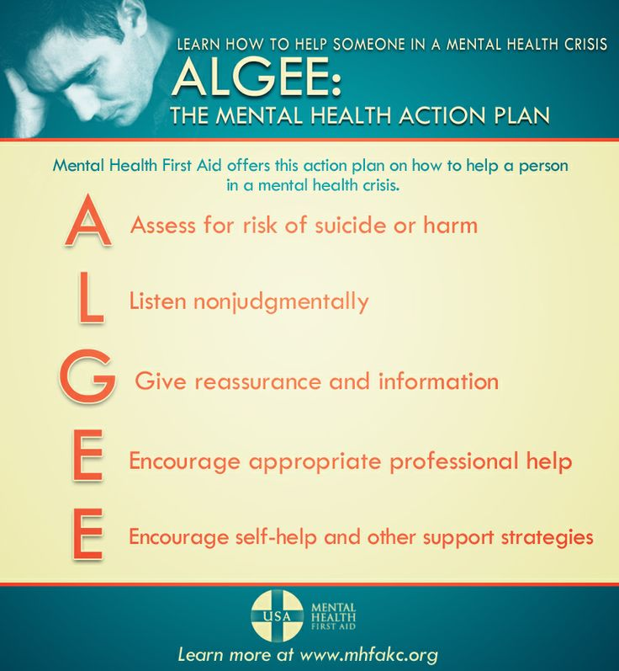

For more information see http://mhfaengland.org/

