Difficulties Proving Identity and Address
One of the main difficulties experienced by both refugees and asylum seekers in using financial services (including opening bank accounts) is proving their identity and their address.
The Financial Conduct Authority’s guidance to opening a bank account can be found here and states the usual kinds of acceptable ID and proof of address.
This guidance also recognises that “Financially Excluded Groups” (including refugees and asylum seekers) may struggle to provide some of this ID and recommend that banks show flexibility in the kinds of proof they ask for.
Prevention of Money Laundering or Anti Money Laundering (“AML”)
In 2003, banks were told to “toughen up” their checks on customers (“Customer Due Diligence”) to prevent money laundering. This made proving address and identity more difficult than before.
The Government guidance issued to Banks on the prevention of Money Laundering also encourages flexibility in dealing with financially excluded groups (p10) but also requires banks who show such flexibility to do more checking and monitoring accounts.
Asylum Seekers
In principle, Asylum Seekers may open bank accounts “if they are entitled to work, to deposit money from abroad, or to receive financial support from the Home Office.” In practice, those without the right to work in the UK will find it very difficult to meet the Proof of ID and Address required to open a bank. Even banks with very enlightened approaches to customer sign-up are often unwilling to open banks for asylum seekers.
Refugees
Refugees may find it easier to open a bank accounts (they will usually have more ID, and proof of an address) but it can still be difficult.
Tactics for proving identity and address ID to a financial service provider
- Gather as much ID and proof of address as possible, using the Prevention of Money Laundering Guidance appendix as guide.
- “A letter from the warden of a homeless shelter… will normally be sufficient evidence” p13
- Letters from the Home Office, or accommodation providers “should be of recent date” p15
- “All documents must be originals” p15
- “Passports, National Identity cards or travel documents must be current ie unexpired” p15
- All documents should be recent originals p14

- Be clear which documents you think provide proof of address, and which is proving identity.
- This will make it easier to know which aspect someone is struggling with, and for them to be able to try and plug the gaps

- Don’t be afraid to show you know what you’re talking about
- In bank jargon, checking someone’s ID and address is sometimes called “Customer Due Diligence” or “Know Your Customer.” Showing you know this will give you credibility.
- If need be, show you are familiar with
  - the Anti Money Laundering Guidance (AML Guidance), and
  - the Financial Conduct Authority’s advice to firms (banks like to be called firms) on AML
- Be prepared to reference this, from Part 2, p15 of the Current JSMLG guidance:
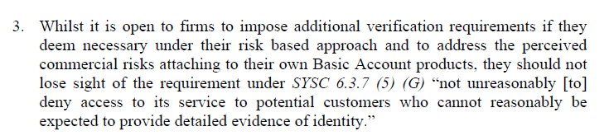

Other Factors
Financial institutions are warned to be extra careful when dealing with people from countries where money laundering is easier than the UK.
People from these countries often experience extra problems because they come from there.
The list of countries is constantly changing so it’s hard to give an up to date list. As you might expect this list is usually made up of countries whose governments are linked with extremists, who are at war, or who have a poor record on upholding the rule of law.

