Pregnancy حمل
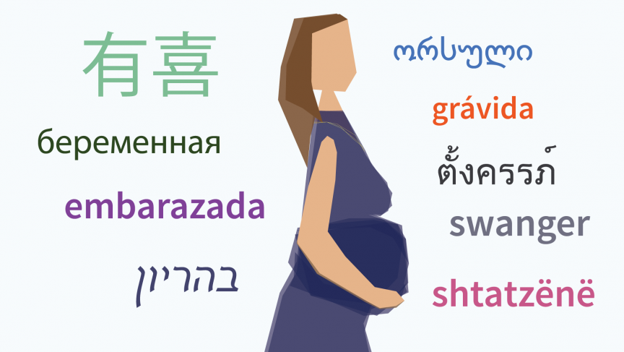
1. Visiting the doctor
2. Medical Conditions
3. Routine checks
4. Ultrasound Scan
5. Where you will have your baby?
6. Hospital Bag
7. Labour
8. How you can feed your baby

- Visiting the Doctor
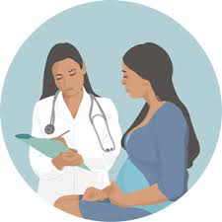
Telling the Doctor you are pregnant.
“ I am pregnant.”
“ I am expecting a baby.”

The doctor will ask you, “how many weeks pregnant are you?” or “when was your last period?”

You can reply “my last period was on (insert date)”
or “I am 4 weeks pregnant” or “I don’t know”.

The doctor will ask if this is your first baby.
You can say “yes it is my first baby” or “no it is not” or “this is my first, second, third, fourth, fifth, six, seventh child.”

Key Words to discuss. * Period * Pregnant *Expecting *First.

Matching Activity
The matching activity on this page will help you to remember these words and their meanings.

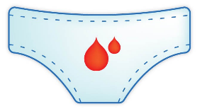 Pregnant

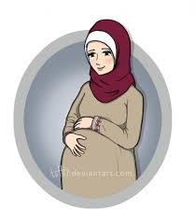 Blood Test

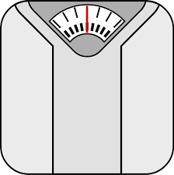 Period

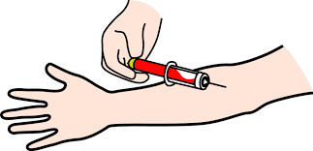 Blood pressure
Weight (scales)

2. Medical Conditions
The doctor needs to know if you have any medical conditions so they can keep you safe in pregnancy.
These are some common ones.

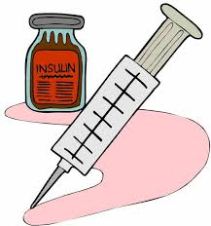 Diabetes

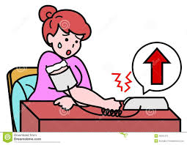 High/low blood pressure

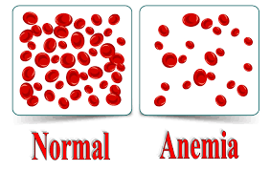 Anemia

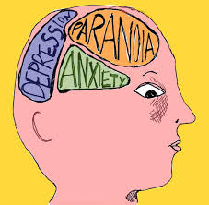 Mental health conditions such as depression, anxiety, bipolar disorder, phobias.
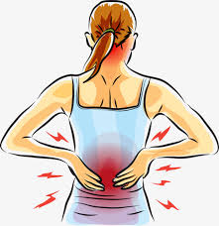 Physical illness such as back pain, leg pain or neck pain.

HIV and Aids.

3. Routine Checks
Each time you visit the GP or Midwife she will do the following checks.

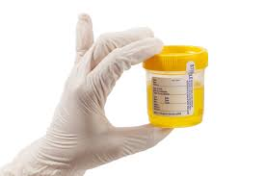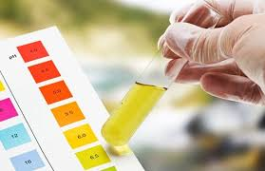 Urine Sample.
Pee in a pot to return at the next visit.
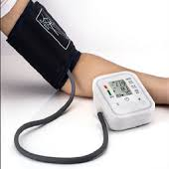Blood Pressure.

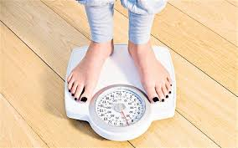 Weight check.
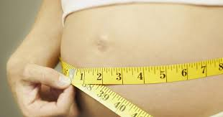 Measure your tummy.

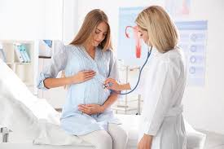 Listen to baby’s heartbeat.

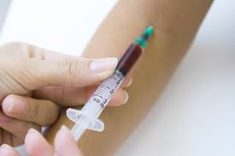 Blood Test.

Routine Appointments Activity

Look at the pictures and talk about what is happening in each one:

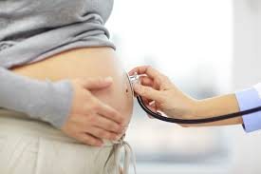
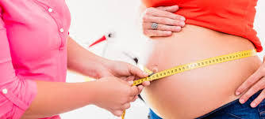
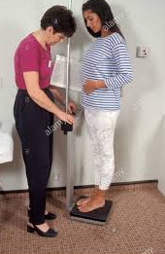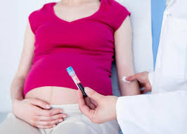
Example Sentences :
- The doctor is taking the woman’s blood pressure.
- The midwife is measuring the woman’s tummy.
- The midwife is listening to the baby’s heartbeat.
- The woman is being weighed.

4. Ultrasound Scan
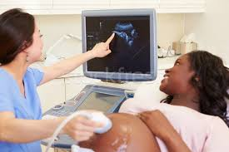
During pregnancy you will have 2 scans to check the health of your baby.
Scan picture.
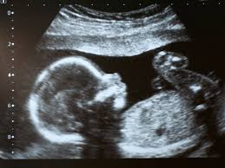
You will be able to buy a scan picture of your baby from the hospital. The scan will happen in the hospital.

5. Where you will have your baby.

Hospital – most women choose to have their baby in a hospital.
The two main hospitals in Leeds are St James and the LGI. Both have maternity wards.

Home Birth – you can discuss options with your midwife if you want to have your baby at home.

6. Hospital Bag
Things you will need to put in a bag to take to hospital when you are in labour.
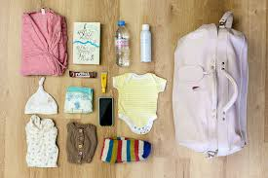
Clothes For you and baby (for 5 days)
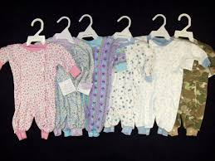

Nappies

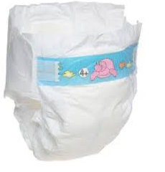
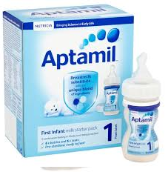 Ready Prepared Formula Milk (If bottle feeding)

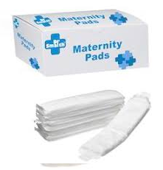 Maternity Pads

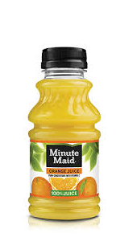 Snacks & drinks

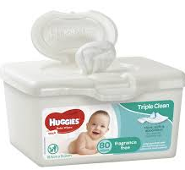 Baby wipes

Shower gel & shampoo 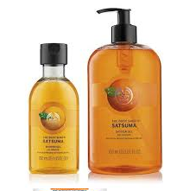
Toothpaste & Toothbrush

Towel & Flannel (For mum & baby) 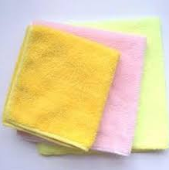

Dressing gown & Slippers. 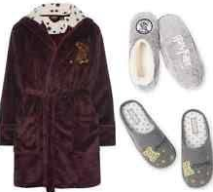

Pyjamas 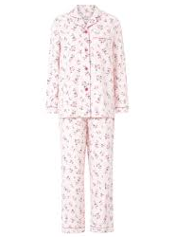

Nipple Cream 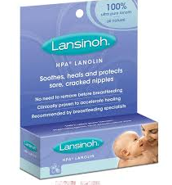

Breast Pads 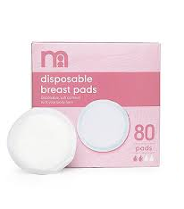

Baby Blanket

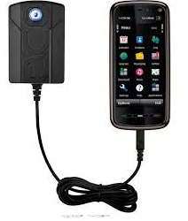Mobile Phone & Charger

7. Labour
Labour is when you have strong contractions which mean your baby will soon be born.
Pain relief options:
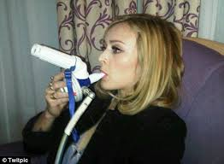 Gas and air.

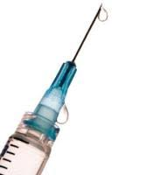 Pethidine/diamorphine
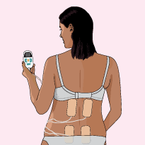 Tens Machine

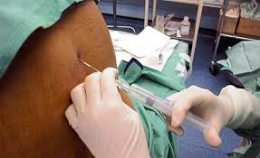 Epidural

Matching Activity – Pain Relief

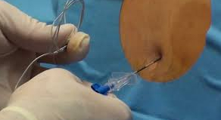 Tens Machine

Pethidine

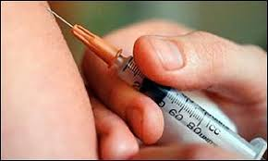 Gas and Air

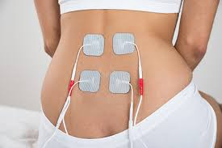 Epidural
When you are in labour the midwife or doctor will ask if they can do an internal examination to check the baby.
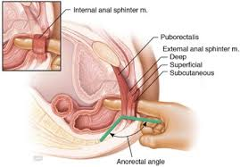

If there are any problems with the baby’s birth they may use the following to help baby be born.

Induced/induction – Start labour.

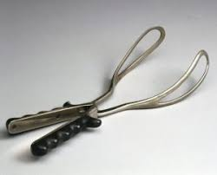 Forceps 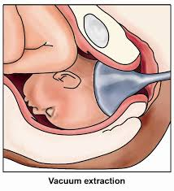Ventouse

If baby is not delivered naturally you may have a caesarean section. This is an operation to remove baby.
It is also known as a C-Section.

After birth useful words/ phrases
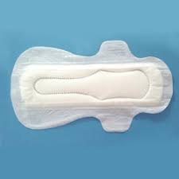 Sanitary Pads.

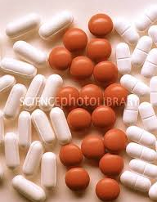 Painkillers – Paracetamol and Ibuprofen

Please can you change the bed?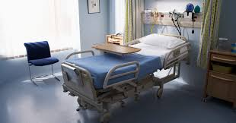

nappy cream

Cotton Wool

Breast Pad

Bed Sheets

Story Activity – fill in the gaps using appropriate words as learned in the booklet.

Aaminah is Pregnant. Aaminah makes an appointment to see her __________.
The doctor asks Aaminah “when was your last period?” Aaminah replies “_____________________________________.”
The doctor asks Aaminah if it is her first _______?
Aaminah tells the doctor this is her second baby, he then checks Aaminah’s ________ pressure and takes a blood _______.

8. Feeding the baby

Formula Milk 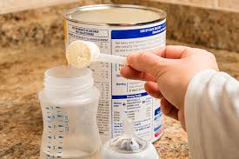

Ready prepared Milk 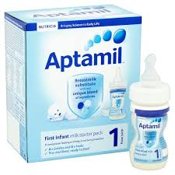

Breast feeding 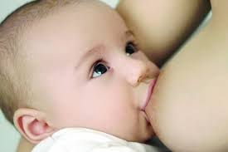

Breast pump 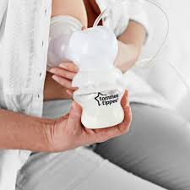

Baby bottle 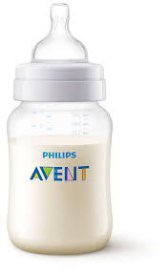
Bottle Teats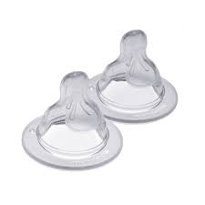

Baby bottle Steriliser

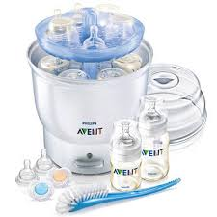
Bibs
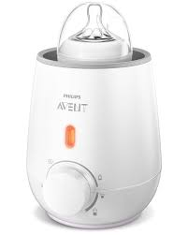 Bottle warmer

Pregnancy and Birth Wordsearch

I A M P F O R M U L A D A Y
T O P OF THE Z O M B F G H
G A S A N D A I R D O U G H
B L A B L O O D T E S T U T H
I L A B O U R I S O N L T Y H K
B S C A R F E S B I R T H S I N
S C O A D E G H T I L M N O P
A A B C B N M O P Q R S T Y V
W X Y Z P U M P E G H Z X U L

Formula
Gas and air
Blood Test
Bibs
Labour
Birth
Pump

