1a Background info on Leeds Asylum Seekers Support Network – Updated November 2018

Background
Leeds Asylum Seekers Support Network (LASSN) works with some of the most at-risk people in the country: asylum seekers and refugees escaping persecution who end up isolated, destitute, with little hope and few choices.
LASSN was set up in 1999 following the Government’s decision to disperse asylum seekers around the country. LASSN had the support of voluntary, community and church groups and was established as a charity in 2001 in response to some of the pressing unmet social needs of refugees and asylum seekers living in Leeds.
Our vision
Asylum seekers and refugees will be safe, respected, supported and empowered to rebuild their lives free of persecution

Aims
LASSN has two aims. The first is to meet some of the social needs of refugees and asylum seekers by reducing isolation, provide advocacy support and encourage self-help. The second is to raise awareness of issues facing refugees and asylum seekers, based on our experiences.

Objectives
LASSN wants asylum seekers to be
- Supported and relieved from hardship and distress by local people
- Empowered to rebuild their lives, to fulfil their potential and to take control of their lives
- Integrated, settled and safe. LASSN wants Leeds to be a place of welcome and understanding and for the general public, organisations, politicians, and policy makers to understand the needs of Asylum Seekers.

How we work
LASSN works in ways which
- are Respectful of the contribution asylum seekers and refugees make to both LASSN and the UK
- are Informed and based on what asylum seekers and refugees say they want and value
- are Empowering of both refugees and asylum seekers, and local people to help and support them
- are based on Partnership - we seek good relationships with other organisations so that asylum seekers and refugees can access the kind of help and support they want and need
- sees Volunteers as vital to effective work with asylum seekers and refugees and recognises how much they benefit from their interaction with refugees and asylum seekers

Organisation Structure
LASSN is a registered company and charity with a voluntary management committee. The Chair line manages the Director. The Director provides line management to all staff; the Finance and Admin Officer provides financial and administrative support; the Volunteer Managers recruit and support volunteers; and the Project Support Officer provides dedicated administrative support for Volunteer Managers . Volunteers undertake befriending, home tutoring and hosting for Grace Hosting. We also have a membership of around 50 people and organisations committed to the aims of LASSN.
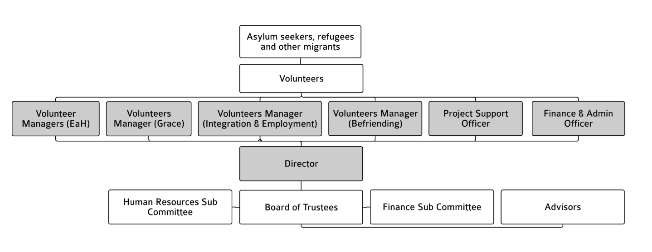

Current Activities
- The Befriending Scheme where volunteer befrienders are matched with asylum seekers and refugees requiring support with accessing services and getting to know locality and culture.
- The English at Home Scheme where volunteer tutors are matched with asylum seekers and refugees unable to get to mainstream English classes because of health / caring issues.
- Grace Hosting - where hosts offer hospitality in their homes (evening meal, bed and breakfast). Hosts either offer emergency accommodation for 1 – 3 consecutive nights to destitute asylum seekers, or longer stay accommodation which can be for weeks and months at a time.
- Connecting Opportunities (Mentoring and Befriending) – offers refugees and other migrants who are thinking about work the chance to build their confidence, improve their English, and to making contacts and friends in their local community, finding out about the help and services available to them.
- Information and Awareness Raising: we write about and talk on asylum issues through conferences and events, newsletters, talks and presentations, contributing to asylum training in the region, partnership working, and by our volunteer training programme where around 60 volunteers a year receive training on asylum issues. We run a number of websites with different purposes
  - http://lassn.org.uk provides information on LASSN and for our volunteers, supporters and funders
  - http://helpinleeds.com is a comprehensive directory of free support services available to asylum seekers and refugees in Leeds
  - http:/migrationpartnership.org.uk provides regular updates and information aimed at people and agencies supporting refugees and asylum seekers in Leeds
  - http://transitionguide.org.uk is a simple guide to the first 6 months of life as a refugee in Leeds.

Beneficiaries
Yorkshire and Humberside is a major asylum dispersal region. Prior to dispersal in Leeds, there were about 2,000 refugees living in the city who arrived here since the late 1970s. Since then we have seen more than 14,000 Asylum Seekers arrive in the city from 110 countries have lived in Leeds, with around 10,000 settling here once they receive their refugee status. In February 2018 there were about 870 asylum seekers in Leeds who received support from the Home Office. Our best guess is that there are another 800 asylum seekers who are not receiving support from the State and who are staying with friends, family or who have nowhere at all.

Many asylum seekers and refugees experience acute isolation, language difficulties and immense uncertainty over their asylum claim. This can result in deterioration in both mental and physical health and well-being.

Most asylum seekers are highly skilled and motivated people, but while they are prevented from working whilst their claim is being assessed. Lack of purposeful activity can lead to a lack of self-confidence and a loss of self-respect and self worth. For example, a young mother who was a respected primary school teacher in Zimbabwe described how in the UK rather than receiving respect she has been made to feel like an unwelcome burden. This can lead to increased depression and anxiety.

For more information on LASSN, and how it fits with other agencies in Leeds, please see our presentation: An introduction to LASSN

